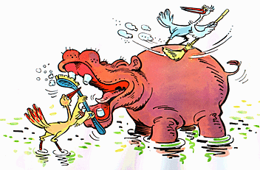
Symbiosis Practice Worksheet
NAME _____KEY_______________

TYPES OF SYMBIOSIS
There are 3 basic types of symbiosis. Don’t forget that symbiosis is the relationship between two organisms of different species that benefit one or both organisms.

M- Mutalism: a symbiotic relationship that benefits both organisms involved
C- Commensalism: a symbiotic relationship that benefits one organism and the other is not helped or harmed.
P-Parasitism: a symbiotic relationship that benefits one organism and the other is harmed.

Complete the chart:

Interaction | Effect on Organism #1 | Effect on Organism #2
Mutualism (M) | Helps/Harms/No Effect | Helps/Harms/No Effect
Commensalism (C) | Helps /Harms/No Effect | Helps /Harms/No Effect
Parasitism (P) | Helps /Harms/No Effect | Helps /Harms/No Effect

Directions:
Put the letter M, C, P by the statement that best describes the type of symbiosis.
__P__ 1. A tick living on a dog and taking its blood for food.
__P__ 2. A tapeworm living inside a cow and absorbing the cow’s nutrients for food.
__C__ 3. A bird building a nest in a tree.
__C__ 4. Orchids growing in tall canopy trees to get sunlight.
__C__ 5. Bacteria living on human skin.
__M__ 6. Bees use a flower’s nectar for food, and they carry a flower’s pollen to other
flowers, allowing flowers to reproduce.
__M__ 7. Bacteria living in the intestine of a cow to help it break down cellulose (fiber).
__M__ 8. A seventh grader and its pet.
__M__ 9. A lichen, a close relationship between a fungus providing water and place to live
while alga provides food.
__M__ 10. Clownfish living in a sea anemone getting food from anemone and keeping sea
anemone clean.
__P__ 11. Dutch elm disease has caused mass destruction of elms. The fungus feeds on
materials produced by the elm trees.
__C__ 12. Small mites live on your skin, eating dead skin cells.
__M__ 13. Crabs try to get a sea anemone to attach to its shell. The crabs drive away seastars
that would eat the anemone and the anemone drives away octopi that would eat the crabs.
__P__ 14. A wasp stings a spider and takes it to its nest where it lays an egg on the spider.
The egg hatches into a larva and the larva eats the spider as a source of food.

