LEMON PEPPER TILAPIA
1c flour
1/3c cornmeal
1/4 t garlic powder
1/4 t salt
2t lemon pepper
1 egg
¼ c. egg beaters
2T butter
2T olive oil
2 Tilapia fillets
Lemon and Parsley

Fish
Place all dry ingredients on a piece of foil.
Set a plate with paper towels to drain the fish after frying on the side.
Beat the egg and egg beaters in a shallow dish.
Dip the fish fillets into the egg mixture then dredge in the dry mixture.
Heat the butter and the olive oil in a large skillet. Medium heat.
Fry the fillets until brown on both sides. Use two turners to gentle turn the fillets. They will cook about 5 minutes on each side.
Drain on paper towels.
Garnish with fresh parsley and lemon slices.

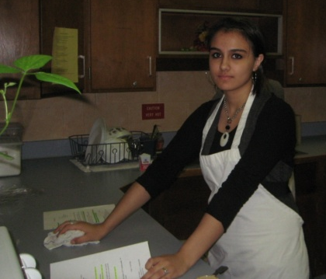
Yield: 4 servings
Steamed Broccoli
Wash broccoli. Cut the florets off the stem.
Place the florets in the steamer basket and the basket in a saucepan.
Put water in the bottom until it hits the bottom of the steamer basket.
Turn on high and cover with a tight lid. Steam for about 5 minutes or until fork tender. Do not overcook or start too early.
Serve immediately.
Almond Pilaf Rice
Place a chicken bouillon cube in 2 cups of hot water and let it dissolve. Chop an onion and place it in a saucepan with 2 T. butter, ¼ c. almonds and 1 c. of white rice. On medium heat, brown the rice (about 7 minutes) then add the water. Bring to a boil (let boil 1 minute) and add ¼ t. salt and an 8th of a t. of red pepper give it one stir and turn down to simmer. Steam for 20 minutes. Let stand for 10 minutes. Fluff with fork.

