UNIT 1 REVIEW FOR TEST Name________________________________________
Number System (1.1)
Be able to classify numbers into all appropriate number systems:
Real, Rational, Irrational, Complex, Imaginary, Integer, Whole, Natural

Properties (1.1)
- Name the property demonstrated:  8 + (-8) = 0  A) Distributive Property  B) Inverse Property  C) Identity Property  D) Associative Property | 2) Name the property demonstrated:  (2 · 5) · 4 = 4 · (2 · 5)  A) Commutative Property  B) Distributive Property  C) Identity Property  D) Associative Property
- Give an example of the Associative Property of Addition: | - Give an example of the Identity Property of Multiplication:

Absolute value (1.7, 2.7, 2.8)
- Solve:
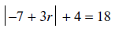

- Solve and graph your solution: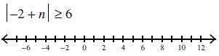 | - Solve and graph your solution: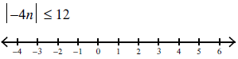
- Graph:  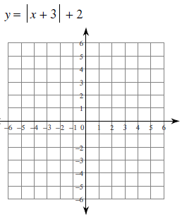 | - Graph:  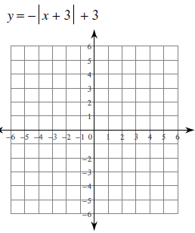

Complex Numbers (4.6)
- Simplify: | - Simplify: |  | - Simplify:
- Simplify:  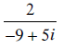 |  | - Simplify:  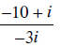

Exponents and Radicals (5.1 and 4.5)
- Write in Radical Form: 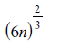 | - Write in Exponential Form: 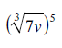
- $Simplify {\left(\frac{x^{2}}{y^{-2}}\right)}^{-4}$ | - $Simplify \frac{2x^{-2}y^{5}}{16x^{3}y^{-2}}$
- $Simplify: \sqrt{150}$ | - $Simplify: \frac{3+\sqrt{7}}{2-\sqrt{10}}$

Apply same properties to Fractional Exponents and Higher Degree Radicals (6.1 and 6.2)
- $Simplify: {81}^{\frac{1}{2}}$ | - $Simplify: {27}^{-\frac{2}{3}}$
- $Simplify: \sqrt[3]{48}$ | - $Simplify: {\left(3^{4}∙5^{4}\right)}^{-\frac{1}{4}}$
- $Simplify: {\left(25a^{10}b^{16}\right)}^{\frac{1}{2}}$ | - $Simplify: \sqrt{\frac{18x^{5}y^{4}}{49xz^{3}}}$

