#### Unit 1 Summary Sheet Name ______________

#### Number Sense, Absolute Values, and Exponents

##### Classify the numbers into all appropriate number systems

**(Real, Rational, Irrational, Complex, Pure Imaginary, Integer, Whole, Natural)**



**Solve and graph each of the following:**



**Graph each of the following using a tables of values:**



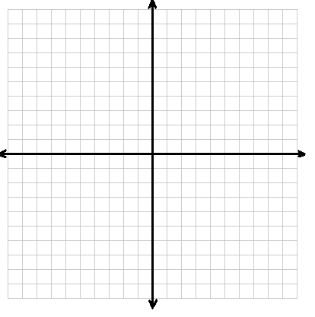

**Simplify each of the following:**



***Give an example of each of the following properties:***

Associative Property for Multiplication/Addition

Commutative Property for Addition/Multiplication

Identity Property for Multiplication/Addition

Inverse Property for Multiplication/Addition

Distributive Property

Transitive Property

Zero Product Property