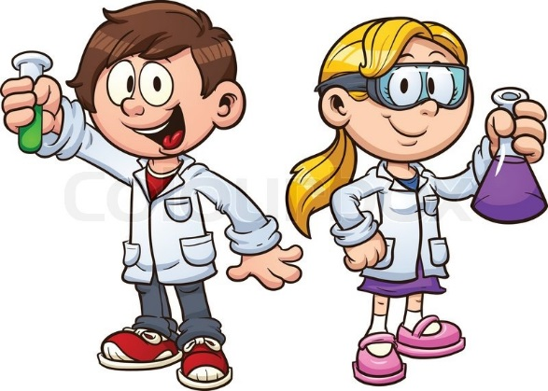
Welcome to Mrs. Horton’s Class!!!!!!!

August 2019

Dear Fifth Graders and Families,

Welcome to Fifth Grade! I am so excited to be your teacher this year, and know we will fill our year with learning adventures and many challenges!

I love teaching, and my favorite grade to teach is Fifth Grade! In fifth grade you really grow to be a leader, independent learner, and a responsible citizen of our school and community.

During our time together this year we will be doing a lot of writing, and of course plenty of math and reading. Some of the fun things include order of operations, long division, and of course more fractions!

In Language Arts, we are going to have lots of fun writing stories and trying to reach the “40 Book Challenge” in Reading. One important note: On the first day of school, I would like you to bring in a book you read this summer!

However, do you know what I love most about fifth grade? SCIENCE! In Science we will do lots of experiments, learn about force and motion, and learn a bunch about the earth- what it’s made of, how it cycles, and why bad things happen like volcanoes and earthquakes! Do you know what STEM is? We will be doing lots of projects that require us to build and test structures and tools! STEM is all about using Math and Science together

I am looking forward to meeting you- I hope to see you at our Open House on August 21st!
Talk to you soon!
In Learning,

Roxanna Horton

