**Geography and Map Skills Unit Study Guides**

**The seven continents**

**Locate** North America, South America, Europe, Asia, Africa, Australia, and Antarctica on maps and globes.

**The five oceans**

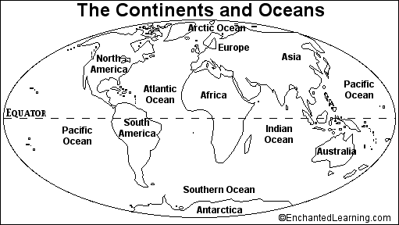**Locate** the Arctic Ocean, the Atlantic Ocean, the Indian Ocean, the Pacific Ocean and the Southern Ocean on maps and globes

* **Continent**: A large body of land on the Earth
* **Ocean**: a large body of salt water

1. **Parts of a Map**-- Map Legend (Map Key), Compass Rose, and Map Title

**\* People use maps to locate places.**

1. **Map Legend (Map Key)** Lists symbols on a map and tells what they stand for

**[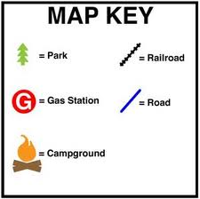](http://www.google.com/imgres?q=map+legends+for+kids&num=10&hl=en&biw=1098&bih=651&tbm=isch&tbnid=4di4PHUDBCEpxM:&imgrefurl=http://www.kidsgeo.com/geography-for-kids/0027-map-key-and-scale.php&docid=xpZAooyB5drubM&imgurl=http://www.kidsgeo.com/images/map-key.jpg&w=300&h=299&ei=2hxeUNnLOIrs0gHmjYHADw&zoom=1&iact=hc&vpx=567&vpy=135&dur=59&hovh=224&hovw=225&tx=91&ty=79&sig=117578441607004552438&page=1&tbnh=134&tbnw=134&start=0&ndsp=18&ved=1t:429,r:3,s:0,i:82)**

1. **Symbols** Drawings located on a map legend that describe places on a map.  **symbol**

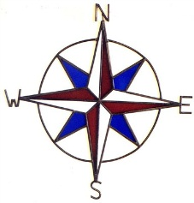

1. **Compass Rose** Shows cardinal directions

on a map. North, South, East, West

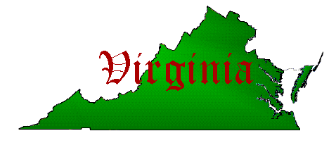

1. **Map Title** The name of a map **Map Title**

6. 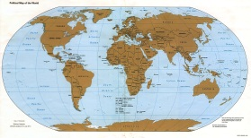 **map  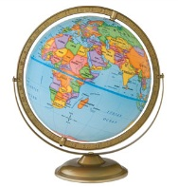 globe**

* flat * round (sphere)

* stretched out pictures * true shape of earth

* drawings or pictures * model of earth

* shows many different places * shows mostly land and water

7. Some ways maps and globes are **alike** :

\***both** have a compass rose

\***both** used in classrooms to teach map skills

\***both** can show continents and oceans

1. [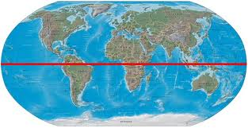](http://www.google.com/imgres?q=equator&num=10&hl=en&biw=1098&bih=651&tbm=isch&tbnid=_Z5wA_e8zVm2eM:&imgrefurl=http://www.britannica.com/EBchecked/media/124435/World-map-with-the-Equator-marked-by-a-red-line&docid=C8mIqhSzZS_z_M&imgurl=http://media-3.web.britannica.com/eb-media/19/129119-004-68F1F761.jpg&w=550&h=283&ei=CSheUIq_Lc6F0QHRvoCwCw&zoom=1&iact=hc&vpx=613&vpy=195&dur=1809&hovh=161&hovw=313&tx=164&ty=92&sig=117578441607004552438&page=1&tbnh=87&tbnw=170&start=0&ndsp=15&ved=1t:429,r:3,s:0,i:148)**Equator**  Imaginary line around the middle of the earth

**equator**