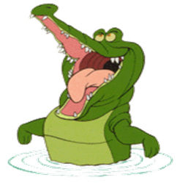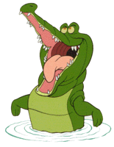

***Science***

***We will continue to investigate the scientific method. We will still continue explore Sound energy. We will continuously review many fourth-grade science concepts as the fifth-grade science SOL is very rigorous.***

**SUPPLIES…SUPPLIES…SUPPLIES…**

**Recyclable materials to make their music makers.**

Materials needed: multiple bottles of Sta-Flo (Walmart, Giant, and/or Target) liquid starch, tempera paint (Blue, brown, green, white, red, black.)

Students will need to bring other supplies for painting and decorating their models based on their teams decision, but will be asking for your permission first.

Please email wendy.nelson@lcps.org if you have any questions about what we need.

Thank you,

Mrs. Nelson

**Dear Parents,**

**We have had a fabulous first quarter of school! I enjoyed discussing your child at our parent teacher conference. If you were unable to make our conference, please contact me, so we can reschedule. This quarter is the beginning of what I call our “Tough Love” quarter. This is when I will hold the students accountable for their choices and decisions to better prepare them for middle school. They need to learn how to persevere through situations that may arise. It may be an uncomfortable situation for them, but they will survive. I will continue to post homework on my website and send weekly assessments and information home in the Thursday folder. I am looking forward to an amazing 2nd quarter~ Mrs. Nelson**

***Language Arts/Reading***

***We have been enjoying exploring our reading units through interactive read alouds, guided reading, shared reading, and independent reading. We are getting ready to begin reading Crash by Jerry Spinelli with our Book Clubs. I am currently reading Wonder to the class and am trying to finish, so we can watch the movie in class. I want the student to compare and contrast the book to the movie and decide for themselves which is better😊***

***Social Studies***

***We will begin touring the Northeast and Southeast regions, along with defining and illustrating the different types of geographical land forms found throughout the world.***

***Math***

***In math, this quarter, we will be covering the following concepts:***

***Elapse time***

***Decimal place value and rounding***

***Adding, subtracting, multiplying, and dividing decimals***

***Probability and Sample Space***

TThe Croc Chronicle

**Fifth Grade Croc’s News**

**November 2019**

# Article Title 3

# Important Dates & Reminders

**\*AEW for 5th grade 11/13 1:45**

**\* Book Fair 12/2 – 12/6**

**\*Winter Party 12/19 @ 1:30**

**\*Harmony Middle School Visit (only students attending HMS will go) 12/18 @ 9:30**

**\*Sing Along 12/20 @ 1:30**

**\*Winter Break 12/21-1/5**