Microsoft Word Test Generator Add-In

To generate tests in Word 2007, click on the Ribbon and choose “Add-Ins”

Under the Educator Tools, choose the Test and Quiz Tools
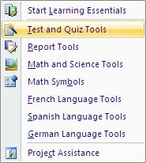

The following task bar will then appear

Select “Create Test”

Create a Test Wizard will appear, from here you can format your test questions
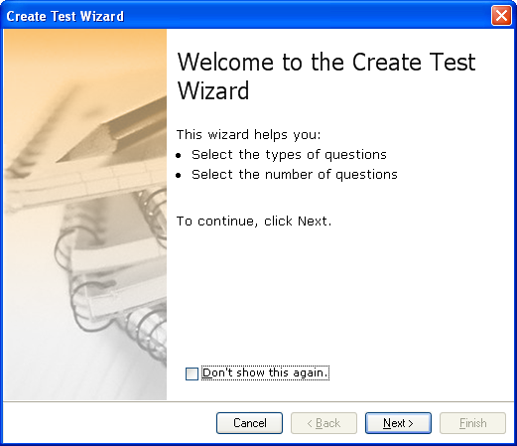

OR
You can simply click directly on the type of question format you choose to use. As you can see, it is possible to change/add different formats quickly within your test

- True False

Note: These “Add-in” options are only available on the LCPS school computers. They are not on single user versions of Office 2007

