ACADEMIC Earth Science Agenda
September 5, 2017: Tuesday - B Day

- SIGNED SAFETY CONTRACTS?????
- TODAY is to REVIEW terms you have had in all your science classes, and what you mastered last class!

WARM-UPS:
- EXC-ELL vocabulary: Angular Measurement
  - Be sure you are in your ASSIGNED groups!
OBJECTIVES: MEASUREMENT REVIEW
- TURN OFF your CELL PHONE and place it in your backpack!
    - To be successful, I need you to be engaged in the learning activities

- Measurement Review – I will give you a NEW DENSITY sheet – fill in as we go!!!
- Angular Measurement Activity
  - Carefully listen to directions
  - Write your answers on your answer sheet as you complete the activity with your group!

HOMEWORK:
- You and a parent/guardian must sign and date the Science Safety Rules and return these to me IF YOU DID NOT TURN THEM IN
- BE SURE you have completed and turned in your angular measurement answer sheet
- Read the ATTACHED notes on the electromagnetic spectrum!

Email: ffrancis@lcps.org

The Electromagnetic Spectrum
The electromagnetic (EM) spectrum is the range of all types of EM radiation. Radiation is energy that travels and spreads out as it goes – the visible light that comes from a lamp in your house and the radio waves that come from a radio station are two types of electromagnetic radiation. The other types of EM radiation that make up the electromagnetic spectrum are microwaves, infrared light, ultraviolet light, X-rays and gamma-rays.
You know more about the electromagnetic spectrum than you may think. The image below shows where you might encounter each portion of the EM spectrum in your day-to-day life.
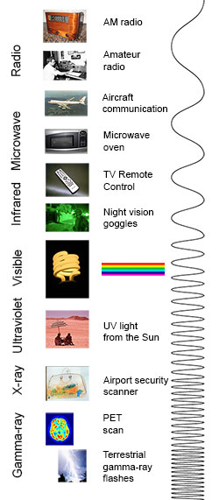
The electromagnetic spectrum from lowest energy/longest wavelength (at the top) to highest energy/shortest wavelength (at the bottom). (Credit: NASA's Imagine the Universe)
Radio: Your radio captures radio waves emitted by radio stations, bringing your favorite tunes. Radio waves are also emitted by stars and gases in space.
Microwave: Microwave radiation will cook your popcorn in just a few minutes, but is also used by astronomers to learn about the structure of nearby galaxies.
Infrared: Night vision goggles pick up the infrared light emitted by our skin and objects with heat. In space, infrared light helps us map the dust between stars.
Visible: Our eyes detect visible light. Fireflies, light bulbs, and stars all emit visible light.
Ultraviolet: Ultraviolet radiation is emitted by the Sun and are the reason skin tans and burns. "Hot" objects in space emit UV radiation as well.
X-ray: A dentist uses X-rays to image your teeth, and airport security uses them to see through your bag. Hot gases in the Universe also emit X-rays.
Gamma ray: Doctors use gamma-ray imaging to see inside your body. The biggest gamma-ray generator of all is the Universe.

Is a radio wave the same as a gamma ray?
Are radio waves completely different physical objects than gamma-rays? They are produced in different processes and are detected in different ways, but they are not fundamentally different. Radio waves, gamma-rays, visible light, and all the other parts of the electromagnetic spectrum are electromagnetic radiation.
Electromagnetic radiation can be described in terms of a stream of mass-less particles, called photons, each traveling in a wave-like pattern at the speed of light. Each photon contains a certain amount of energy. The different types of radiation are defined by the the amount of energy found in the photons. Radio waves have photons with low energies, microwave photons have a little more energy than radio waves, infrared photons have still more, then visible, ultraviolet, X-rays, and, the most energetic of all, gamma-rays.

Measuring electromagnetic radiation
Electromagnetic radiation can be expressed in terms of energy, wavelength, or frequency. Frequency is measured in cycles per second, or Hertz. Wavelength is measured in meters. Energy is measured in electron volts. Each of these three quantities for describing EM radiation are related to each other in a precise mathematical way
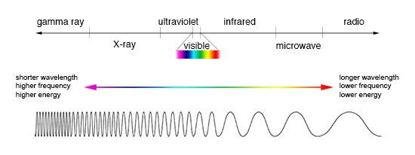
Comparison of wavelength, frequency and energy for the electromagnetic spectrum. (Credit: NASA's Imagine the Universe)

Why do we put telescopes in orbit?
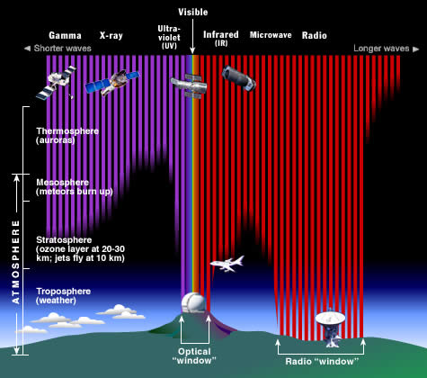
The Earth's atmosphere stops most types of electromagnetic radiation from space from reaching Earth's surface. This illustration shows how far into the atmosphere different parts of the EM spectrum can go before being absorbed. Only portions of radio and visible light reach the surface. (Credit: STScI/JHU/NASA)
Most electromagnetic radiation from space is unable to reach the surface of the Earth. Radio frequencies, visible light and some ultraviolet light makes it to sea level. Astronomers can observe some infrared wavelengths by putting telescopes on mountain tops. Balloon experiments can reach 35 km above the surface and can operate for months. Rocket flights can take instruments all the way above the Earth's atmosphere, but only for a few minutes before they fall back to Earth.
For long-term observations, however, it is best to have your detector on an orbiting satellite and get above it all!

NAME:
Angular Measurements Answer Sheet
Sample Measurements
Angles | Experimental Angular Separation | Accepted Angular Separation
B U T
B U N
B X O

__________1
__________2
__________3

Angle | Direction | Drawing/Sketch
4

270⁰

5 | EAST
6

225⁰

________7
________8
_______________9 Increase/decrease? Explain!

Location | Angular size
10.
X
11.
Y

12.

13. a.
b.
c.

14. a.
b.
c.

