Academic Earth Science
September 21, Thursday: B Day
- You will need your agenda and attached notes from last class
WARM-UPS:
- Review ExC-ELL vocabulary activity: Electromagnetic & Visible Light Spectra
- Check the HW worksheet
OBJECTIVES:
- Complete the notes on the Electromagnetic and Visible Light Spectra
  - Partner Reading – take your notes. Choose a partner (can be group of 3 IF we have an odd number of students)
  - Alternate reading the notes: Each student reads a sentence – followed by your partner on the next sentence
    - Summarize the notes you just read

HOMEWORK:
- COMPLETE the electromagnetic spectrum worksheet
- Re-read your notes on the 3 types of visible light spectra
  - Be sure you answered the questions!
- Read the attached information on the Big Bang Theory (astronomy, NOT TV!)

Electromagnetic Spectrum
- Electromagnetic Spectrum:
  - All forms of Radiant Energy
  - Emissions (energy) from Stars in the form of WAVES
  - Produced by Fusion (thermonuclear reaction: Hydrogen is fused to form Helium in the core of stars)
  - Each Wavelength (λ = lambda) is a different type of radiant Energy
  - WAVES:

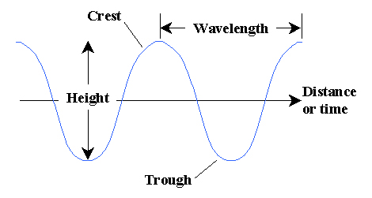

Radio Waves longest λ
Microwaves
Infra Red

Red longest λ (visible light)
Orange
Visible Light Yellow
Green
Blue
Violet shortest λ (visible light)
Ultra Violet
X-rays
Gamma rays shortest λ
- Hot bodies (stars) emit mostly shorter wave radiations (UV, X-ray, Visible light)
- Cool bodies (planets) emit mostly long wave radiation (IR = ‘heat’ wave)

