APES AGENDA: September 1, Thursday: B Day

- Be sure I have all groups’ timelines – WITH NAMES
- Turn in your HW – critique, question writing, concerns
- Turn in your science safety contract!
  - Be sure you and a parent/guardian signed and wrote the date on it

WARM-UPS:
https://www.youtube.com/watch?v=aRG4ySdi_aE
https://www.youtube.com/watch?v=TQmz6Rbpnu0
Austin’s Butterfly: https://vimeo.com/38247060

I WILL ASSIGN BOOKS AS YOU COMPLETE THE WARM-UPS
- Using your time-line activity and geologic Time scale (last class), differentiate among the following:
  - Eon
  - Era
  - Period
  - Epoch
- What criteria is used to differentiate among the eras, periods, and epochs?
- Which era lasted the longest? WHY?

OBJECTIVES: Earth Systems and Resources
- Assigning Cell Phone Parking Spaces
- HOW OLD IS THE EARTH?
  - Your Geologic Time Scale
    - Compare the simple geologic time scale with the current version
      - Discussion of your observations!
      - Discussion of the ANTHROPOCENE
- strengths and weaknesses for the new epoch
- NOTES: Informal
  - Earth’s 4 Spheres
  - Biotic vs. Abiotic components of Earth
- NOTES: Formal:
    - Nebular Hypothesis, differentiation of Earth, beginnings of life
    - http://home.snc.edu/takamasatakahashi/login/AstroSp10/Animations/Active_Figures/nebular/
    - POWERPOINT
TAKE-AWAY: Do this with your group
- Comment on what you gained from constructing your time-line
- Identify Earth’s 4 Spheres
  - Describe the interactions among the spheres – use concrete examples to illustrate your interactions:
    - EX. Interaction between the geosphere and hydrosphere = a volcanic eruption on the sea floor
HOMEWORK:
1. READ THE LAB – EVOLUTION of Earth’s atmospheres, oceans, and sediments
2. BE SURE I HAVE YOUR LAB SAFETY CONTRACT!
3. Begin the first readings listed in your course outline
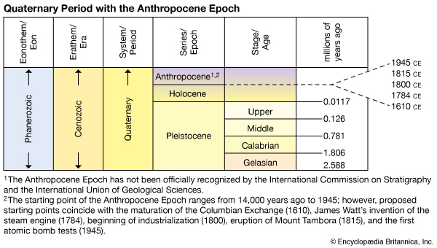The
POSTED ON 17 MAY 2010 IN BUSINESS & INNOVATION CLIMATE ENERGY SCIENCE & TECHNOLOGY SCIENCE & TECHNOLOGY SUSTAINABILITY NORTH AMERICA

