Academic/ELL Earth Science AGENDA
March 9, Friday: B Day

- Take out your agenda from last class (Wednesday, Mar 7) and turn to the word bank you used Wednesday

WARM-UPS:
- I will return your quiz from last class
  - Sit with your partner – we will complete the quiz 1st
CONTENT OBJECTIVE:
- Today you will understand that:
  - freshwater resources are influenced by geologic processes and the activities of humans. Key concepts include:
- Identifying sources of fresh water including rivers, springs, and aquifers, with reference to the hydrologic cycle
- Earth’s fresh water supply is finite. Geological processes, such as erosion, and human activities, such as waste disposal, can pollute water supplies.
Language Objective: Today you will:
- Identify the location and percentages of all Earth’s water
- Demonstrate your understanding of river/stream evolution after reading “The Journey of a River” and “Classifying Rivers – 3 Stages of River Development”
- Describe how the stream/river features form, how they change/evolve over time, and if they represent youthful, mature, or old-age river characterisitics

OBJECTIVES: Surface Waters
- PowerPoint Notes – Stages of a River (my documents, ch 13 -14, power points, stages of a river)
  - Follow along with your notes (some of you received these last class
- LAB ACTIVITY
  - Deposition in deltas, rivers/streams, lakes and ponds
    - Look at the lab attached to this agenda
    - Work with your lab group to complete the lab
      - I AM GOING to enforce the lab safety rules.
      - My expectation is that you will complete the procedures for setting up your jar

HOMEWORK:
- TEST Corrections: On a separate sheet of paper, write the COMPLETE question, letter AND complete correct response to all missed answers.
- Review your notes

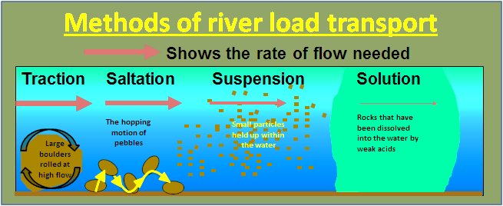
Sediment
http://geology-guy.com/teaching/iac/animations/stream_processes.htm
stream evolution link

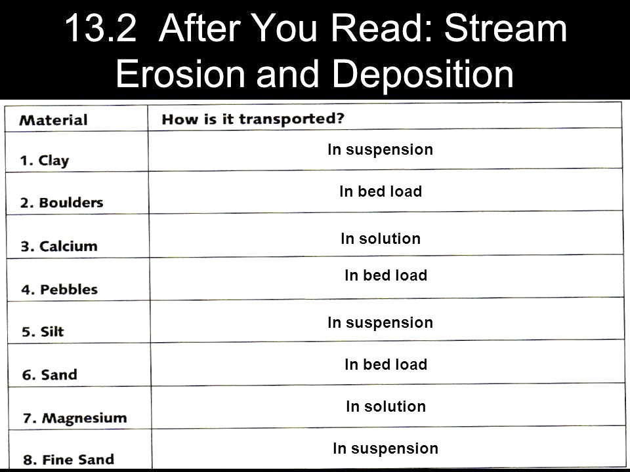

CH#13 Vocabulary Review (Why do you think I made the title blue?)
(Review: Recognition Game Terms)
- You may talk ONLY to your partner during this activity
- Take out a sheet of paper and a writing instrument
- After viewing each slide, write the appropriate term on your paper – be sure to number your responses!
- KEEP YOUR PAPER COVERED! High score could reap major rewards!!!

WORD BANK
BED-LOAD
DEPOSITION
DIVIDE
EROSION
FASTEST
FLOOD (FLASH FLOOD)
FLOODPLAIN
GRADIENT
HIGHEST ELEVATION
MEANDER
MOUTH
OX-BOW LAKE
RIVER SYSTEM
SOLUTION
SUSPENSION
TOPOGRAPHIC MAP
TRIBUTARIES
WATERSHED

Methods of Sediment Transport
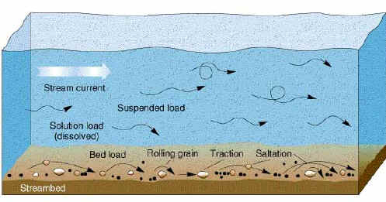
2
Dissolved
1
3
Identify the 3 main methods of sediment transport
Identify the energy needed for each method of sediment transport (how the stream moves sediment) Numbers on next slide

- Energy level that corresponds to method #1
- Energy level corresponding to method #2
- Energy level corresponding to method #3
(high, medium, low energy)

- The slope of the river/stream is called the _____.

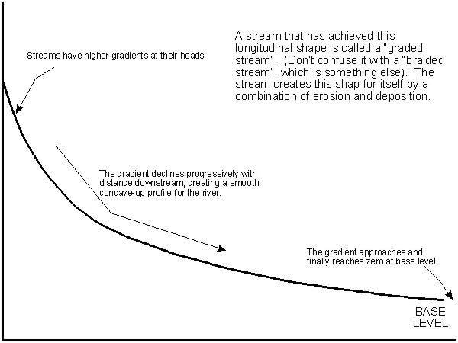

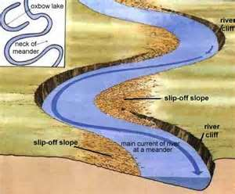
9
8 Describe the speed of the water represented by the arrow
10 The Curve of the stream

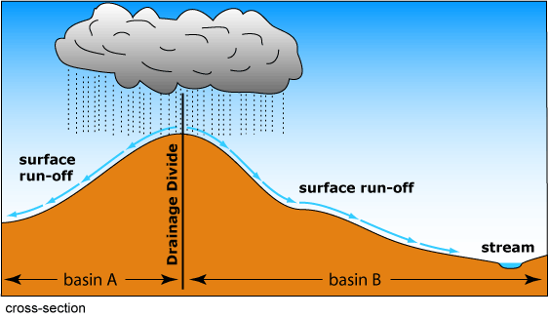
11
11 Name that feature!

12. What type of map do you need to locate feature #11 (previous slide)?

13. SPECIFICALLY, WHAT are you looking for on this map?

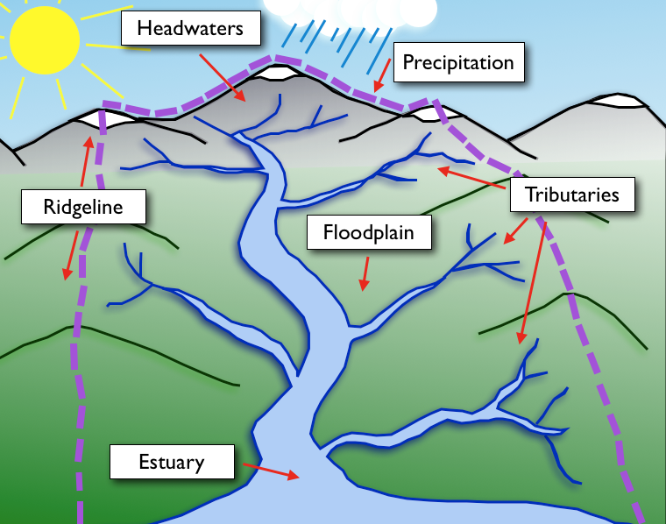
14
15 flat land
16
17. The overall picture (all the land between the dashed, purple lines)

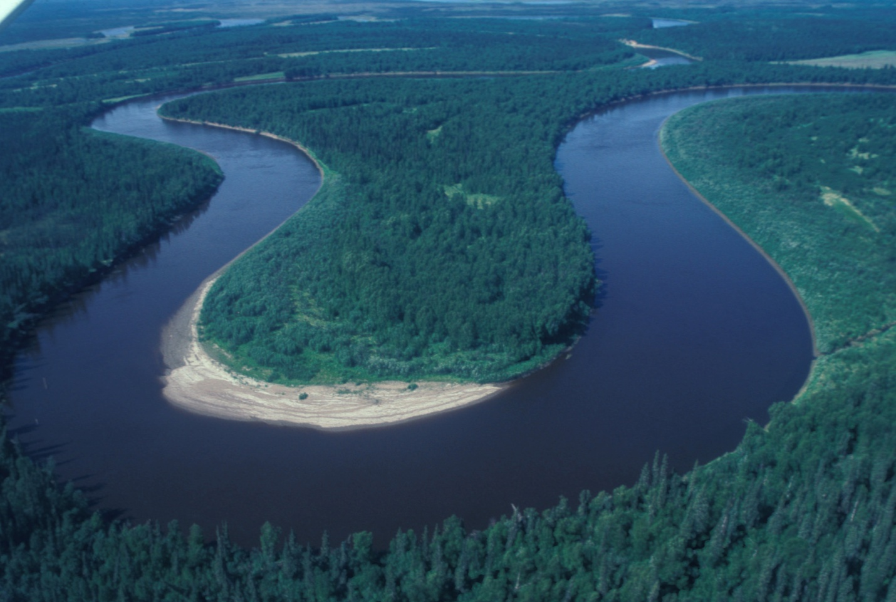
18 What occurs here?
19 What occurs here?

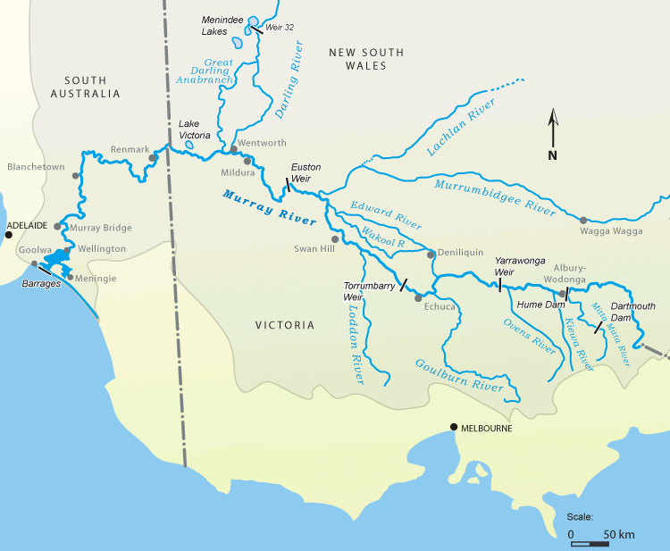
20. JUST the rivers and branches (the BLUE!)

21 No need to explain!
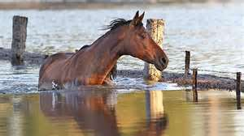
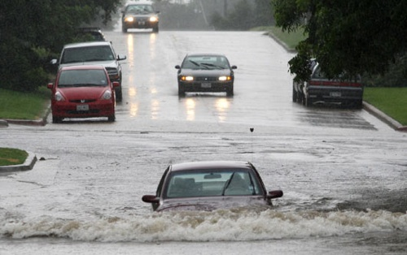

NAME:

LAB ACTIVITY: DEPOSITION IN DELTAS, RIVERS/STREAMS, LAKES, AND PONDS

QUESTION/PROBLEM:
How does energy of water relate to sediment size during deposition in deltas, rivers/streams, lakes, and ponds?
- List 2 factors that determine the energy of water in rivers and streams.

- List the characteristics of sediment that determine how much energy is needed for deposition to occur.

MATERIALS:
COARSE SAND
FINE SAND
GRAVEL
PEBBLES
SILT
WATER
SCOOP/SPOON
PROCEDURES:
- Use the scoop/spoon to add materials from each of the containers (coarse sand, fine sand, gravels, pebbles, and silt) into your jar (be sure you have a lid!!)
- Fill the jar ½ - ¾ full with WATER
- Put the lid on the jar and close it TIGHTLY
- Gently shake the jar FOR APPROXIMATELY 1 MINUTE to mix all the material
- Use the tape to write your group name on the jar.
- Place the jar on the back sink.

Answer the following:
- Sketch a profile (side view) of a stream.
  - Steepest slope at the headwaters, less steep at the middle, most gentle slope at the mouth
  - Label where EACH of the sediment types you used in lab would be deposited in the stream.
    - BRIEFLY explain your answer

OBSERVATIONS
- YOU WILL MAKE OBSERVATIONS EACH CLASS TO RECORD CHANGES IN YOUR JAR
 | DAY 1 | DAY 2 | DAY 3 | DAY 4
COARSE SAND

FINE SAND

GRAVEL

PEBBLES

SILT

OVERALL
APPEARANCE

(DESCRIBE OR DRAW)

CONCLUSION:
- What did you observe when you stopped shaking the jar?

- What happens to the different materials in rivers/streams when the water slows down?

- What factors determine the speed of water in rivers and streams?

