Academic/ELL Earth Science AGENDA
February 23, Friday: B Day

- TEST CORRECTIONS – IF you did NOT turn these in last class:
  - Write your name on your corrections sheet and staple to your answer sheet
  - Ms. Hutson will collect these
- TAKE OUT YOUR Soils Texture Triangle HW
  - You may use this on the test

WARM-UPS:
- Questions on the HW?

Quick DISCUSSION of the Content and Language Objectives
CONTENT OBJECTIVE:
- Today you will understand that:
  - weathering, erosion, and deposition are interrelated processes. Weathering is the process by which rocks are broken down chemically and physically by the action of water, air, and organisms. Erosion is the transport and removal of weathered material. Erosion terms are examples of “mass movement”
  - Soils are arranged in layers/horizons
  - Soils are classified by the percentage of sand, silt, and clay.
    - This is determined using a soil texture triangle
Language Objective: Today you will take the Weathering, Erosion, and Soils TEST

OBJECTIVES: Weathering, Erosion, and SOIL
- TEST: Weathering, Erosion, Soils
  - AFTER the test:
    - Take the Assessment – review of weathering/erosion/soils and pre-test information on rivers/streams
https://jeopardylabs.com/play/soil-weathering-and-erosion
HOMEWORK:
- Complete the Assessment if necessary – IF you complete this, I will use it to add points to your test
Halite forms Rock Salt
Clay forms Shale
Limestone forms from Calcite
Mechanical weathering is dominant
Ice or Frost Wedging
Causes potholes
- Read the attached notes:
  - What is a river system?
  - Water Cycle and All the World’s water
  - 3 methods of sediment transport

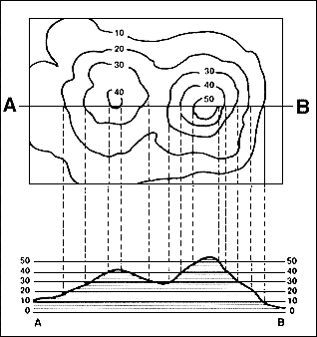
Constructing Profiles

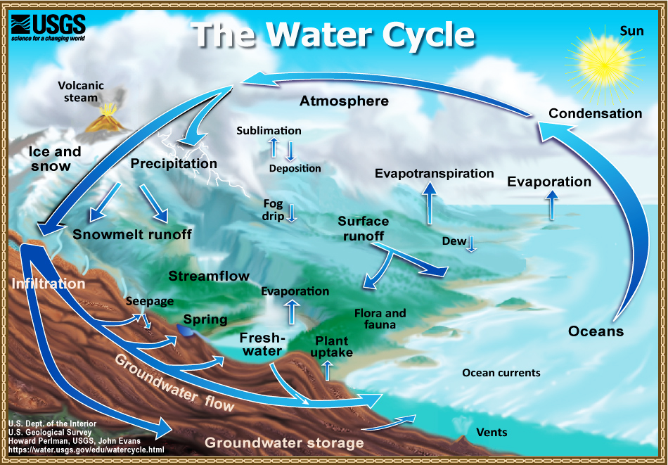

NOTES: The Water Cycle & All the World’s Water

Earth’s Hydrosphere

Water exists in 3 states of matter at normal temperatures and pressures at Earth’s Surface:

Water Vapor – in the atmosphere

Liquid Water - oceans, rivers systems, lakes, ponds, reservoirs, and ground water

Frozen – ice caps and glaciers

Percentages of Earth’s Water

97% Oceans

2 – 2.3 % frozen in ice-caps and glaciers

.3 - .6% Groundwater

.02% Inland lakes, seas, rivers, streams

.009 % Atmospheric Water

Water Cycle: The continuous movement of water from the atmosphere, surface and groundwater zones.

Phase Changes or Changes of States of Water

Water moves from one location to another

Some movement requires a phase change (change of state)

Condensation

Evaporation

Freezing

Melting

Sublimation

Transpiration

Some movements do NOT require a phase change

Infiltration

Precipitation

Run-off

Vocabulary Terms & Phase Change Diagram

Melting evaporation

SOLID LIQUID GAS

Freezing evaporation

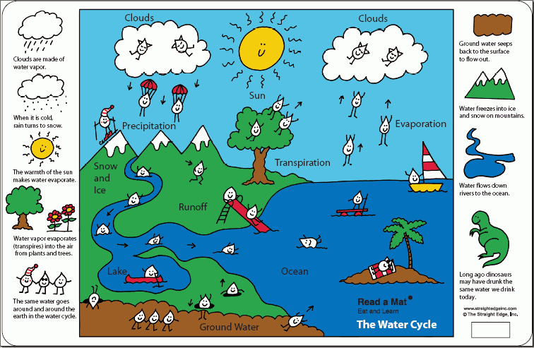

Notes: CH#13.1: Streams & Rivers
- River Systems
  - River systems include the river and all of its tributaries
  - Overland flow of water accumulates in permanent bodies of running water.
    - Streams
    - Rivers
  - Small streams run into larger streams
    - Tributary
      - All tributaries carry sediment
      - Sediment transport depends on speed of the running water
        - Volume (of water)
        - Slope
  - Watershed
    - Drainage Basin
    - All the land that drains into the river
      - Direct drainage through rivers
      - Tributary flow
  - Divide
    - High land that separates watersheds/drainage basins
    - Continental Divide
      - Major Divide in the US
      - Located in the Rocky Mountains.
      - Rain falling EAST of the Rockies drains into the ATLANTIC Ocean
      - Rain falling WEST of the Rockies drains into the PACIFIC Ocean
  - Mississippi River System
    - Largest River System in the US
    - Located between the Continental Divide and the Appalachian Mountains
- Characteristics of Streams & Rivers
  - Ability of River/Stream to erode and transport sediment depends on velocity of the water, the stream’s gradient, discharge, and shape of the channel.
  - Velocity
    - The speed of the water or distance traveled in a given time
    - The higher energy, the greater the velocity
    - Faster water erodes materials more quickly
    - Faster water carries heavier sediments
    - Steeper slopes have faster water
    - Straighter channels (path of the stream) have faster water
  - Gradient
    - Slope
    - Gradient changes from the Head (beginning) to the Mouth (end) of the stream
    - Generally, steeper slopes/gradients are located at the Head of the stream
    - Least steep slopes (gentlest gradient) is usually located at the mouth of the stream
    - The Geology affects stream gradient
      - Least resistant rocks weather/erode most rapidly
      - Most resistant rocks erode slowly
  - Discharge
    - The volume of water passing a given point in a specified time period
    - Varies over the length of the stream/river
      - Increases downstream as tributaries add water (except in deserts)
      - Seasonal variation due to availability of rainfall
  - Channel
    - The path of the stream
    - Velocity is dependent on size & shape of the stream channel
    - As streams meander (wind back & forth) water has greater contact with sides and bottom of the channel
      - Water slows due to increased friction
http://uwp.edu/~li/geos101/ch10/07_StreamProc.swf
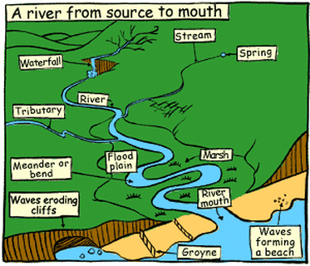
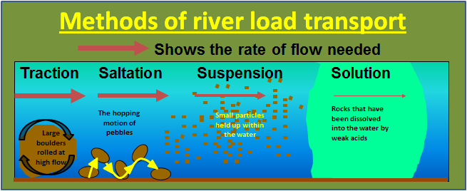
Sediment

