Academic/ELL Earth Science AGENDA
April 4, Wednesday: B Day
- Take out your agenda from Monday, Mar 19

WARM-UPS: CAREFULLY LISTEN TO INSTRUCTIONS
- We will review the groundwater zones, artesian formations, and water table wells

CONTENT OBJECTIVE:
- Today you will understand that:
  - freshwater resources are influenced by geologic processes and the activities of humans. Key concepts include:
- Identifying sources of fresh water including rivers, springs, and aquifers, with reference to the hydrologic cycle
- Earth’s fresh water supply is finite. Geological processes, such as erosion, and human activities, such as waste disposal, can pollute water supplies.
Language Objective: Today you will:
- Using a diagram, differentiate between water table wells and artesian wells
- List the factors that contribute to Karst Topography
  - Describe/Identify the subsurface geology (rock)
  - Label the cave features that form
- Outline the Chesapeake Bay watershed using what you have learned about watersheds, topography, and divides

OBJECTIVES: Groundwater Zones and Karst Topography
- NOTES: GROUNDWATER, WELLS, and KARST TOPOGRAPHY
  - KARST topography and CAVES
https://www.youtube.com/watch?v=PpbxFpAZmSQ 3-D animation
https://www.youtube.com/watch?v=e G9b_xOLXCE follows animation: subtitles
https://www.youtube.com/watch?v=DEaSCs661h8 review of terms – subtitles
- NOTES: Cave formations (dripstone)
- Chesapeake Bay Watershed Map Lab
  - Work in your group to complete the lab
- TEST REVIEW: Questions?
EXIT TICKET: IF we have time:
- Choose a partner for the word sort
  - Ms. Hutson and I will select the group of 3 if there is an odd number
  - Take out your groundwater notes fom Mar 19
  - Match the definitions to the groundwater vocabulary terms
  - Ms. Hutson and I will check your work
  - Fill out your vocabulary chart/table
  - Keep the chart but return all slips of paper back into the baggie and return the baggie to Ms. Hutson or Mrs. Francis
HOMEWORK:
- Complete the test review (March 21 agenda): TEST on surface and groundwater on FRIDAY
Test REVIEW: Water Moving Underground & Review of the Water Cycle
Label the Groundwater Zones.
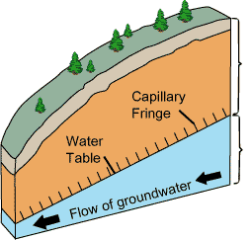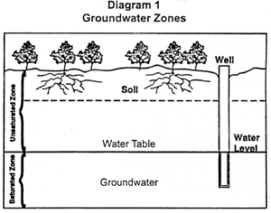
C
E
D
f
C
D
E
A
B
D

Identify the following locations on the diagram:
______ 1. Capillary fringe
______ 2. Dry section
______3. Soil water storage
______4. Water table
______5. Zone of aeration
______6. Zone of saturation

Identify which of the following affect the depth of the water table. If it is a factor, choose “a” = “yes”. If it is not a factor, choose “b” = “no”.
______7 Season a = Yes b = No
______8 Climate
______9 Condensation
______10 Type of impermeable rock (under the zone of saturation)
______11 Soil thickness
______12 Slope

______13 Which of the following best represents the relationship between depth of water table and
well-water levels?
A B C

Water table rises, well level Water table lowers or rises, Water table rises, well level
Decreases; Water table sinks, Well water level remains rises; Water table falls, well
Well level rises the same. Level decreases

______14 Which of the following best represents groundwater near wells after usage?

A B C D

____________________39 Term used

____________________15 Term used to describe permeable rocks or deposits (sediments) that
transmit and carry water in sufficient quantities to supply wells.

______16 Which diagram represents a water table well? (Choose from A & B below)
______17 Which diagram represents an artesian well? (Choose from A & B below)
A B

18 -19 Which description best fits the groundwater in the following locations (Choose from A, B, C):
- Warm all year
- Warm in summer, cool in winter
- Average annual temperature for the region
Drawing NOT to scale:
Surface
18 (0 – 20 meters)

19 (1,000+ meters)
_____ 18
_____19

____________________ 20 What type of bedrock is found in Karst topography?
________________________________________21 List one other feature of Karst topography.

Diagram the cave formations in the space provided:
a. Column or pillar
b. Stalactite
c. Stalagmite

Phase Changes, Water Cycle, & “All the World’s Water”
_____25. The majority of Earth’s water is located in/as
- Atmospheric water
- Inland lakes, rivers, streams
- In Ice Caps & Glaciers
- Groundwater
- Oceans
_____26. The majority of Earth’s fresh water is located in/as
- Atmospheric water
- Inland lakes, rivers, streams
- In Ice Caps & Glaciers
- Groundwater
- Oceans
_____27. The majority of Earth’s useable fresh water (Where we get the majority of our freshwater).
- Atmospheric water
- Inland lakes, rivers, streams
- In Ice Caps & Glaciers
- Groundwater
- Oceans
_____28. The hydrosphere involves water located in which of the following?
- Atmosphere
- Geosphere
- Both a & b

Phase change diagram
Carefully examine the phase change diagram and use the information to answer the following:

29 30.
Solid
Gas
Liquid
32 31

33
_________________________29 (Phase change)
_________________________30
_________________________31
_________________________32
_________________________33
_____34. The cooling processes include
- 29 & 30
- 29 & 32
- 31 & 32

The Water Cycle: Label the diagram of the water cycle.

\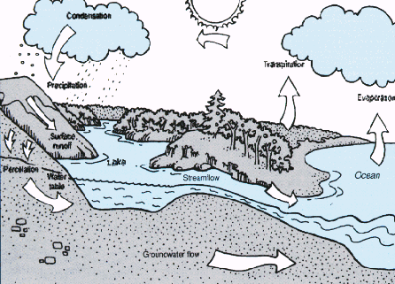
37
37
40
38
39
36
35
2010 International Water Law Project
- Condensation
- Evaporation
- Infiltration
- Precipitation
- Run-off
- Transpiration

Surface Water Test Review
1. Vocabulary: Using a diagram, illustrate and label the following vocabulary
terms:
- Watershed
- Tributary
- River System
- Drainage Basin
- Divide
- Gradient
- Discharge
- Channel
- Describe how channel shape and water flow will change in a river/stream over time.
- Describe the relationship among energy and the 3 ways in which rivers/streams transport/carry material.
- Compare & contrast depositional & erosional features of streams/rivers. Identify these features by name.
- Compare & contrast flash floods & river floods
- Using a diagram, illustrate the parts of young rivers/streams, middle-aged rivers/streams, and mature rivers/streams. Discuss the changes in energy and direction of erosion (vertical vs. horizontal) and the effect on formation of stream features.
- Discuss the headward erosion in rivers/streams and compare this with the erosion evident in waterfalls, including the explanation of why waterfalls are continually moving back.

Karst Topography: Differentiate among Stalactites, Stalagmites, and Columns or Pillars. Where do you generally find these features?

NAMES:
Chesapeake Bay Watershed: Mapping Activity

- Use the attached answer sheet to complete this lab activity

Read the attached information on the Chesapeake Bay:
Write a brief description of a watershed/drainage basin
- What is the Chesapeake Bay (physiographic feature)?
- DESCRIBE the Chesapeake Bay Watershed
Outline the Chesapeake Bay Watershed on your map.
- What is the name of the line you drew?
- What feature would you look to find if this was a topographic map?
- How many major rivers are tributaries (smaller streams that feed larger streams/river
systems) to the Bay on the WEST side of the Bay?
- How many rivers/streams are tributaries to the Bay on the EAST side?

Use the attached map to name the Rivers on the WEST side of the Bay

RIVERS
____________________8 _______________________12
____________________9 _______________________13
____________________10 _______________________14
____________________11

________________________ 15. Which river contributes the MOST water to the Chesapeake (based on size of the WATERSHED)?

Identify ALL of the states/districts that have watersheds that drain into the Chesapeake Bay (how many states affect the Bay?)

________________________________16 ___________________________________20
________________________________17 ___________________________________21
________________________________18 ___________________________________22
________________________________19

NAMES:
Chesapeake Bay Watershed Map Lab Answer Sheet
Complete the chart for questions #1 - #3
Watershed/Drainage Basin DESCRIPTION | Chesapeake Bay (physiographic feature) | Chesapeake Bay Watershed DESCRIPTION

Chesapeake Bay Watershed Outline
______________________4 ____________________15
______________________5 ____________________16
______6 ____________________17
______7 ____________________18
______________________8 ____________________19
______________________9 ____________________20
______________________10 ____________________21
______________________11 ____________________22
______________________12
______________________13
______________________14

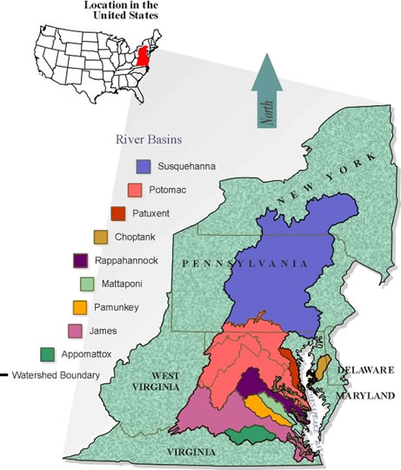

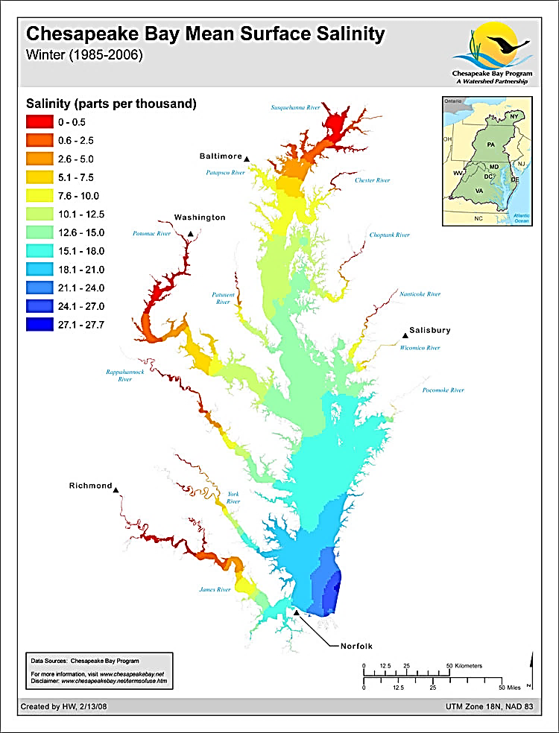
Patapsco
River

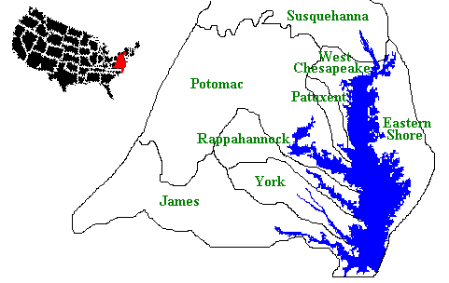

Bay Geography. The Chesapeake Bay is an estuary: a body of water where fresh and salt water mix. ... The Bay itself is about 200 miles long, stretching from Havre de Grace, Maryland, to Virginia Beach, Virginia. The Bay's width ranges from four miles near Aberdeen, Maryland, to 30 miles near cape Charles, Virginia.

