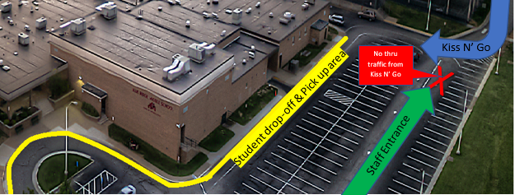

Dear BRMS Families,
There is a considerable increase in the use of the Kiss N’ Go due to the colder weather. With student safety in mind, we need to remind all drivers to follow the established route for drop-off and pick-up shown in the diagram attached. (please open the diagram)
Drivers who enter via the staff parking lot or choose to go straight after dropping students off in non-sidewalk areas are creating a safety concern. Additionally, these drivers are blocking the flow of traffic for drivers exiting via the established Kiss N’ Go route leading to frustration in our school community.
Kiss N’ Go Reminders:
- Enter the Kiss N’ Go loop from the marked entrance to the of the building and loop around the building.
- Drop-off and pick up ONLY on the sidewalk areas adjacent to the school. Student should NOT cut across the parking lot at any time.
- Drop off early to eliminate congestion that is occurring near the 8:35 tardy bell. The building is open at 8:00 a.m. for students.
- The traffic patterns are not directed by staff as we are monitoring students within the building, attending meetings, etc. We as ask our community to respect all families by following the established expectations.
Thank you in advance for your cooperation. We appreciate your commitment to student safety and creating a positive school community.

