9 | Dogbane  Apocynum cannabinum | 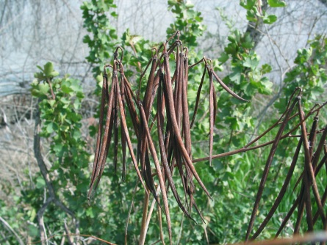  Red branching stem  Paired Seed pods  Milky Sap | This milkweed look alike is considered a noxious (toxic) weed. Its scientific name literally means “go away dog!” This plant is poisonous to livestock and humans, and if ingested can cause cardiac arrest and has many cancer causing properties. Native Americans would use dogbane as a source of fiber, earning it the nickname Indian Hemp, and the fibers can be woven into rope for nets, fishing lines and clothing. The word cannibis in the species name refers to its hemp abilities, not its hallucinogenic counterpart.

