**Science SOL 5.3 Notes**

Use notes from Science SOL 5.3 PowerPoint to complete

**Light**

**What is Light?**

* Light is a form of **­­­­­­­­­­­­­­­­­­­_____________________________**
* Light travels in **___________________________** waves
* It has both **_____________________** and **____________________** fields and is referred to as electromagnetic radiation

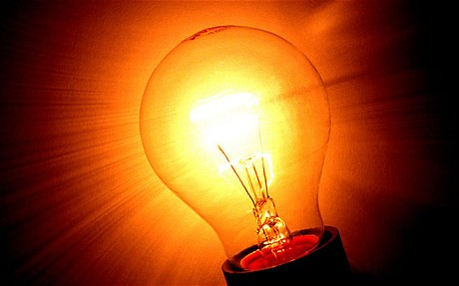

**How Does Light Travel?**

* Light travels in **__________________** paths called **______________** and do not need a medium (solid, liquid, or gas) through which to move
* **___________________-** the straight line that represents the path of light
* **___________________-** a group of parallel rays

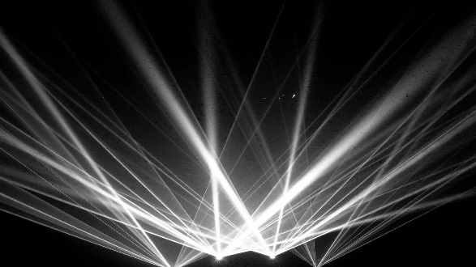

**Parts of a Light Wave**

* **___________________-** the distance between two consecutive waves, usually measured crest-to-crest or trough-to-trough
* **___________________-** the highest point on a wave
* **_______________-** a valley between two waves or the lowest point of a wave
* **___________________-** the number of waves passing a given point in one second

***the greater the frequency, the greater the amount of energy

**Draw a Light Wave**

**Light is a Form of Energy**

* Light waves are waves of **____________________**
* The amount of light in a wave is related to its **____________________**
* **___________**frequency light has **______________** energy
* **___________** frequency light has **______________** energy
* The more **_________________________** in a light wave in a given period of time, the **___________________** the energy level

**Frequency of a Light Wave**

 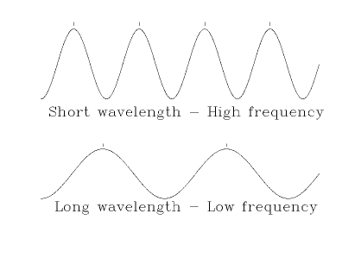

**Electromagnetic Spectrum**

* The entire range of electromagnetic radiation (light) is called the electromagnetic spectrum

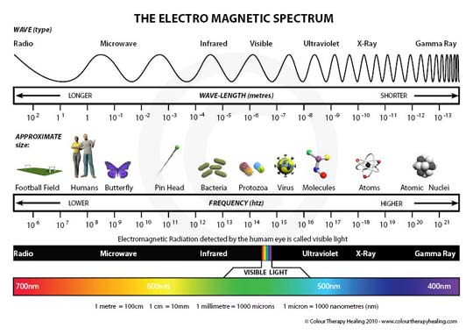

**Visible/White Light**

* Within the electromagnetic spectrum, the area that we see as light is known as “**_______________________**” or “**__________________________**”
* Of the visible light, **_____________** would have the **__________________** wavelength and **_______________** (purple) has the **__________________**

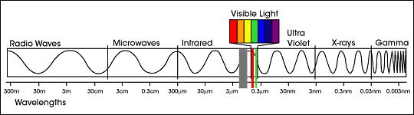

**Visible/White Light**

* The white light/visible light that we see is really a combination of several different **______________________** of light traveling together
* These wavelengths are represented by the colors: **___________**, orange, **_____________**, green, **______________**, and violet
* Acronym to remember order of visible light: **________________________**

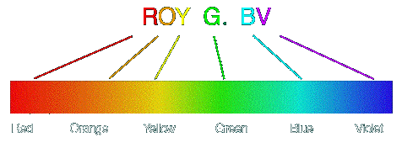

**How Light Passes Through Objects**

* Light passes through some materials **___________________** and does not pass through other materials at all
* The terms **______________________**, translucent, and opaque indicate the amount of light that **______________________** through an object

**Transparent**

* Allows **________________________** light to pass though
* Examples: **_____________________**, clear plastic wrap, **_______________________**, air

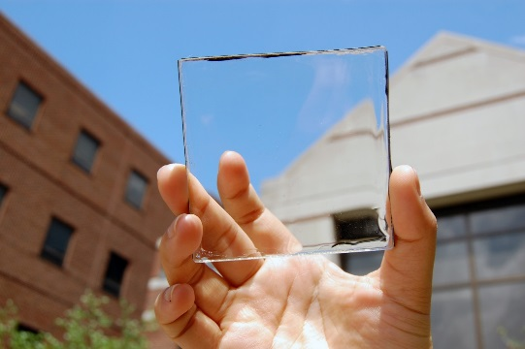

**Translucent**

* Allows **______________________** light to pass through
* Examples: **___________________**, frosted glass, **___________________**, some plastics, and **_______________________**

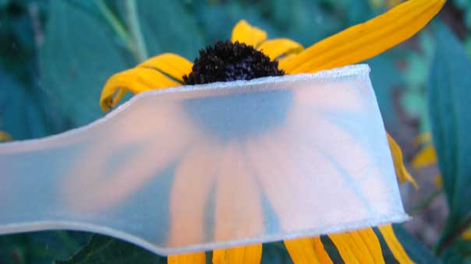

**Opaque**

* Does **__________________________** light to pass through
* Examples: **______________**, wood, **________________**, aluminum foil, and **_________________________**

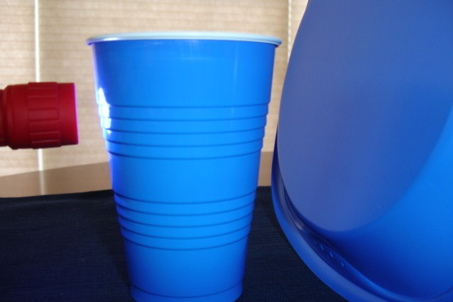

**When Light Hits an Object**

* Light travels in **__________________________** until it hits an object
* It can bounce off an object or **__________________**
* It can be bent or **____________________**
* It can pass through an object or **___________________**
* Or it can be absorbed as **_______________**

**Reflection**

* Light **________________________** an object
* **_____________________________** objects are better at reflecting light than other objects (ex. mirrors)
* When light bounces off a **___________________** surface, it is scattered in many directions

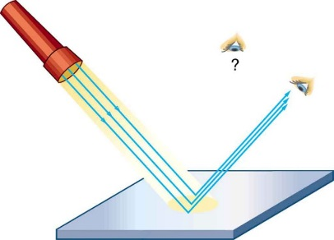 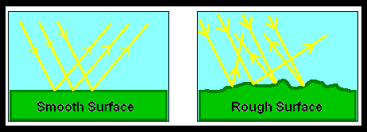

**Law of Reflection**

* The Law of Reflection states that when light hits a surface, the **_________________** at which it is reflected (bounces off) is the **_________________** as the angle at which it strikes

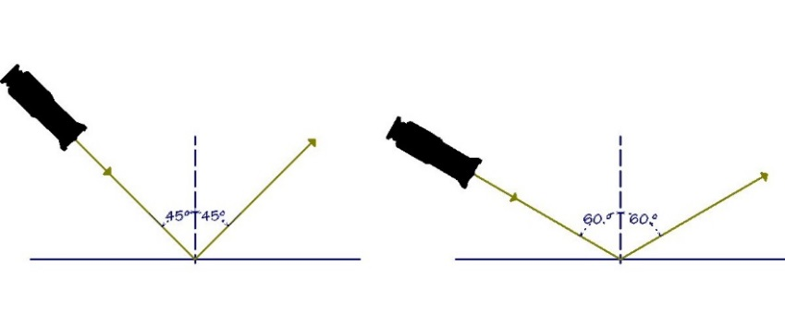

**Reflecting Colors**

* The**_________________**of an object is the color of the light it reflects
* Grass looks green because it is **__________________** green light and **_____________________** all the other colors

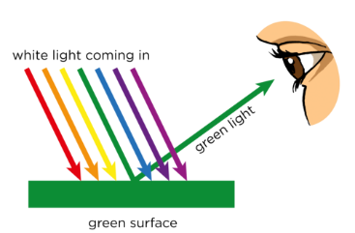

**Black and White**

* Black and white are **______________________** on the spectrum
* Black is when a material **__________________** all of the visible light and no light is reflected back
* White is a **____________________** of all visible light together

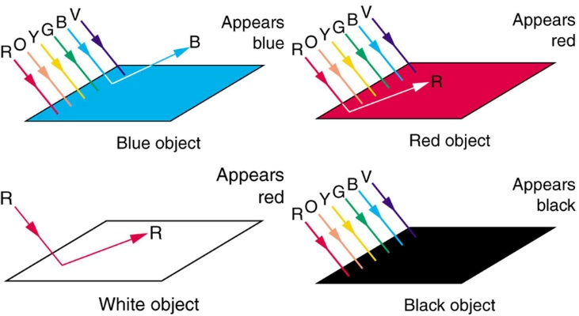 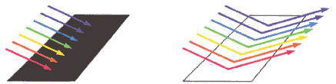

**Refraction**

* Light travels in straight lines, but when it passes at an angle from one transparent medium to another, it can be **____________________** or **_________________**.
* The speed of light **_______________** as it passes from one transparent object to another.
* The speed of the light wave changes, but its frequency **__________________**.

**Refraction**

* The amount of bending of the light wave depends on:

1. The **__________________** of the material it is entering
2. The **__________________** of the light wave
3. The **__________________** at which the original light wave enters the new medium

**Examples of Refraction**

* A setting sun looks **__________________** instead of round
* A straw appears to **__________________** when it is placed in a glass of water
* Objects appear **___________________** in water than they actually are

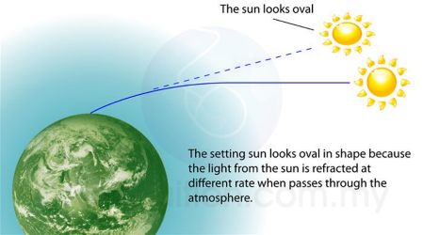 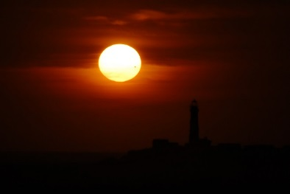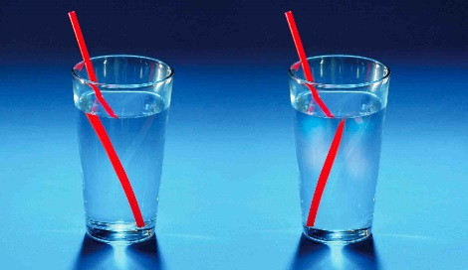 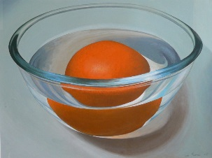

**Prisms**

* A prism can be used to **___________________** white/visible light
* When the different wavelengths of light in white light pass through a prism, they are **__________________** at different **___________________**(refracted)
* The colors of light we see are red, orange, yellow, green, blue, and violet

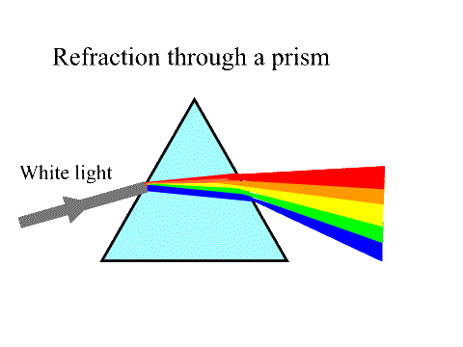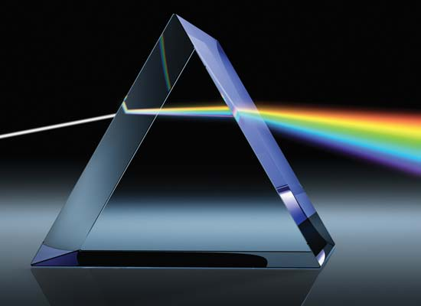

**Rainbows**

* A rainbow is an example of both **refraction** and **reflection**
* Sunlight is first **refracted** when it enters the surface of a spherical raindrop
* It is then **reflected** off the back of the raindrop, and once again **refracted** as it leaves the raindrop

