WH&G I Agenda 2017 Mon. 1/9 & Tues. 1/10

Greece Part 2
END OF UNIT OBJECTIVES:
- Evaluating the significance of the Persian and Peloponnesian wars.
- Characterizing life in Athens during the Golden Age of Pericles.
- Citing contributions in drama, poetry, history, sculpture, architecture, science, mathematics, and philosophy, with emphasis on Socrates, Plato, and Aristotle.
- Explaining the conquest of Greece by Macedonia and the formation and spread of Hellenistic culture by Alexander the Great.

DAILY OBJECTIVES:
We will:
- Describe Greece’s Golden Age.
- Differentiate between the Greek columns: Doric, Ionic, and Corinthian.
- Take notes about the different Greeks who made an impact on today’s world.
CLOSURE - By the end of today I will be able to:
- Examine Pericles’ role in leading Athens into the Golden Age.

WHAT ARE WE DOING TODAY? :
- WARM UP
- PASS BACK TESTS
- GOLDEN AGE NOTES
- IMPORTANT GREEKS
- CLOSURE

HOMEWORK
- Greece Part 1 Remediation due Jan. 18 (A) and Jan. 19 (B)
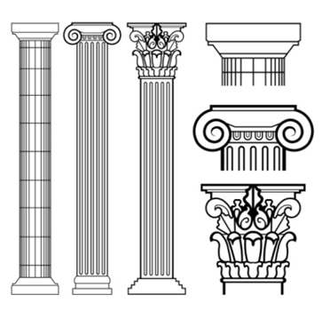

Greece Part 2 Calendar

1/5 & 1/6: Persia/Greece Test
1/9 & 1/10: Golden Age of Athens
1/11 & 1/12: Important Greeks
1/13 & 1/17: Alexander the Great
1/18 & 1/19: Greece Part 2 Test

WARM UP
WORD BANK: Myceneans Dorians Minoans
- Who moved into the Greek world and reigned for about 400 years and left no written record?

- This group of people once lived on the island of Crete, dominating trade in the Mediterranean before the Greeks.

- This group dominated the Mediterranean after the Minoans and before the Dark Ages of Greece.

- All of the following are true of the Persians EXCEPT:
  - they were tolerant of conquered people
  - they used battering rams, archers, and iron tipped spears to attack cities
  - they constructed the 1,500 mile long Royal Road
  - they developed an imperial bureaucracy

- Judging from the map, what conclusions can you draw about the economy of ancient Greece?

  - It probably relied heavily on fishing and trade
  - It probably relied on agriculture
  - It probably relied on its colonies
  - All of the above are true

- Both the Minoan and Mycenaean civilizations

  - focused on overland trade
  - influenced later Greek civilization
  - lacked a written language
  - were warlike peoples

CLOSURE

How did Pericles extend democracy?

How did Pericles glorify Athens?

