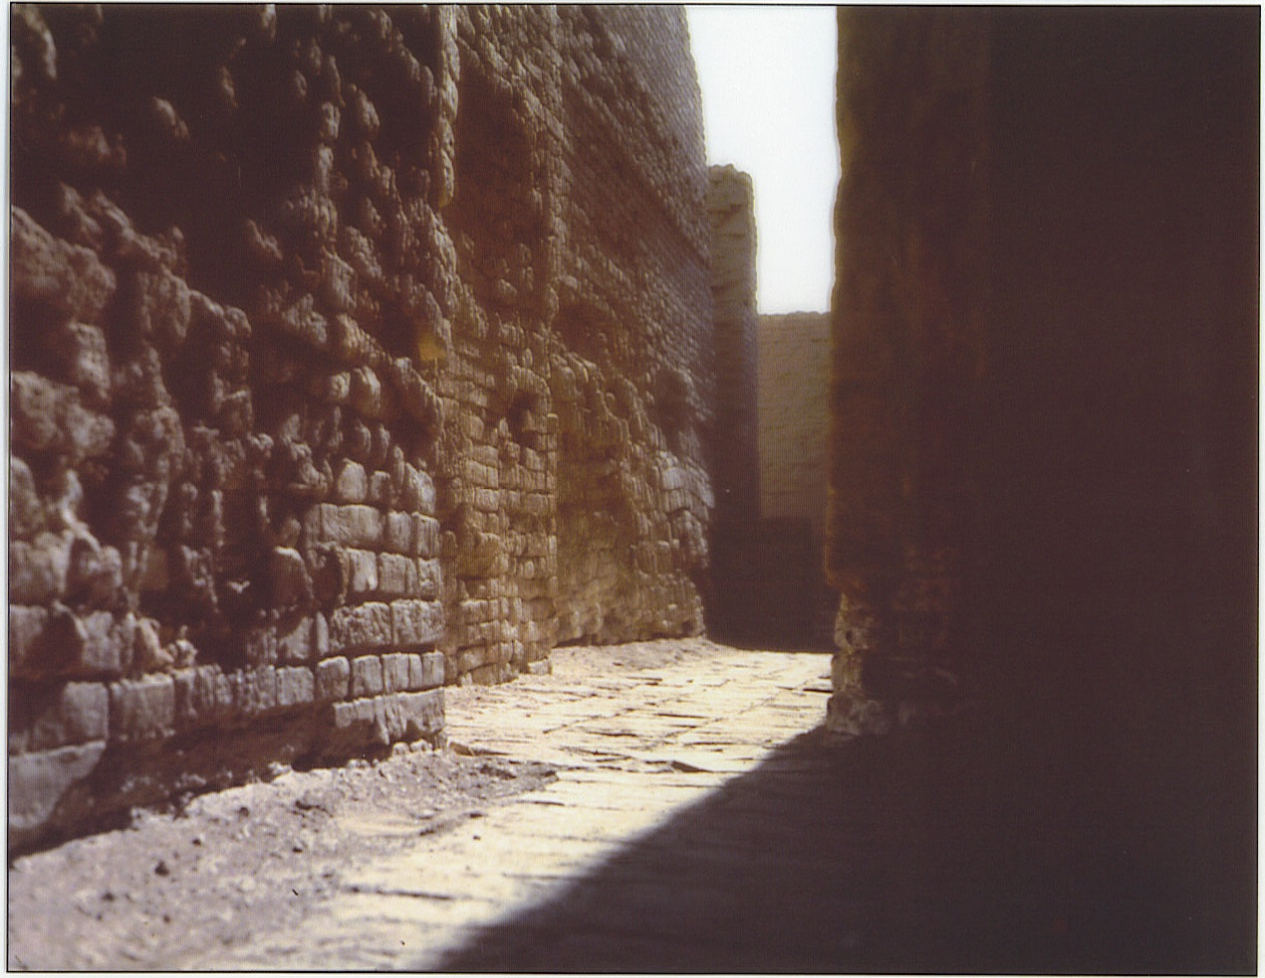
This is a picture of the ruins of several homes alongside a narrow alley. Most of Mohenjo-Daro’s people lived in the lower city, an area to the east of the citadel and three times its size. Rows and rows of flat-roofed, two-story, mud-brick housed lined the streets. The houses’ windows were typically located on the second floor, were narrow, and were covered with screens made of hard clay called terra-cotta or a translucent mineral called alabaster. The houses’ outside walls faced narrow alleys and their inside walls faced an open courtyard. Many of the houses had indoor bathrooms that drained into the main sewer system that ran throughout the city streets. Archeologists have excavated housed containing one room and houses containing more than a dozen rooms. They have speculated that the one-room houses belonged to the poorer citizens of Mohenjo-Daro and the multiroom houses to the wealthier.

