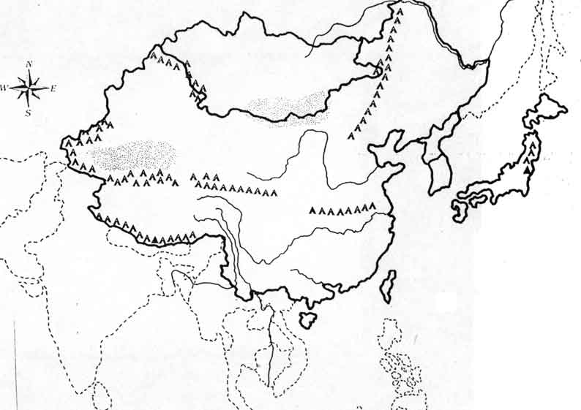
WHI – Ancient China Map Use pg. 47 in the textbook or Chapter 2 Section 4 page 51.
Geographic Features: Himalaya Mtns., Taklimakan Desert, Gobi Desert, Plateau of Tibet
Bodies of Water: Pacific Ocean, Huang He River, Yangtze River
Cities: Anyang
Color: Use two different colors to illustrate the region that was inhabited by both the Shang and Zhou Period.

Color the area on the time line below that corresponds with the time of Ancient China:
3500 B.C.E. 2500 B.C.E. 1500 B.C.E. 500 B.C.E. 500 C.E.

3000 B.C.E. 2000 B.C. E 1000 B.C.E. 0

